

Feed Batch Weighing System
Installation & Operation manual

Table Of Content
- System Scheme
- System Description & Features
- Mechanical Installation
- Electrical Installation – System & Cards
- Cards coding & Pairing
- Operational Instruction

System Scheme

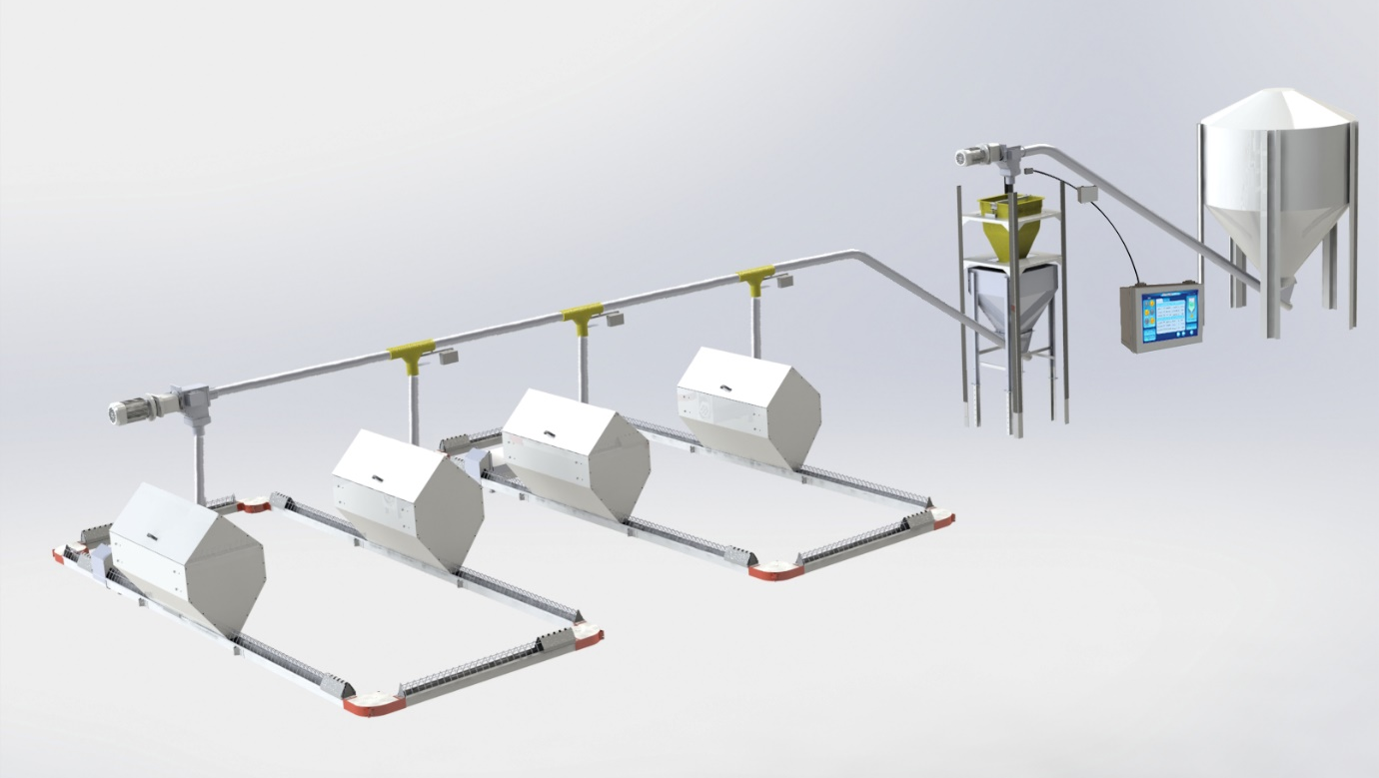

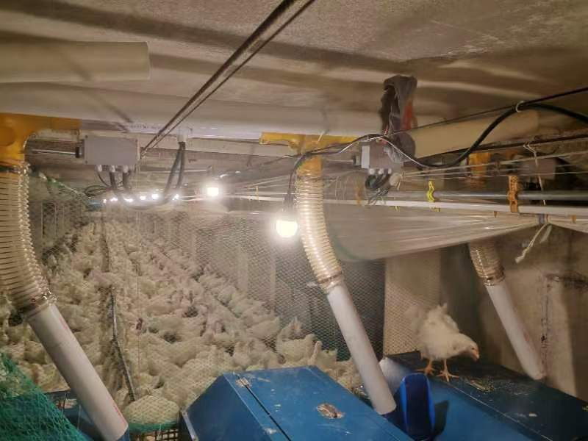
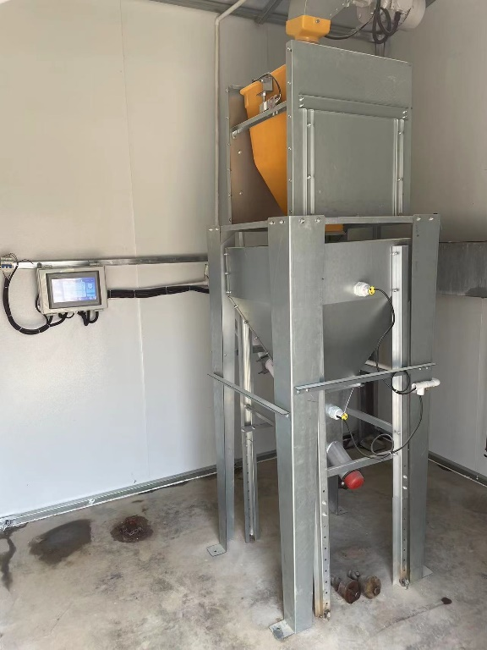

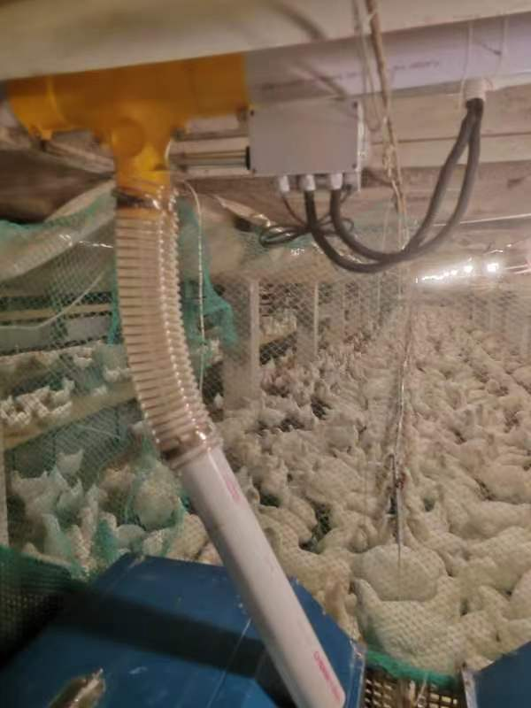
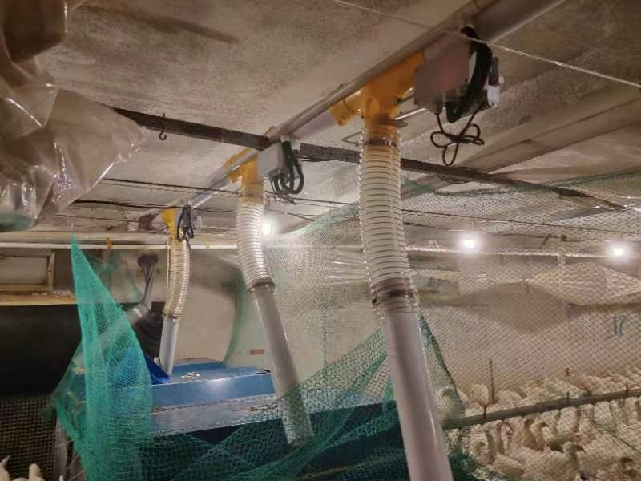
System Description & Features

Some growing protocols require portioning and weighing of the feed.
Plasson system weighs and control the feed distribution into the chicken house. The system controls the feeding components; thus, the system allows the flexibility to program and operate multiple feeding systems simultaneously.
- Simple Calibration and smart weight compensation guarantee high accuracy - 0.5% of feed portion.
- 10” Inch touch screen.
- Manual & Automatic modes.
- Weighing plans can be adjusted for Breeder Broilers, Rearing Pullets, Commercial Layers and Broilers.
System Scope:
- Augers from Silos to weighing station.
- Weighing system
- All cross augers from Weighing station into the house
- Motorized feed T-drops
- Feeding system (Chain Circuits / Pan Loops / Pan Lines)

Capacity:
- Up to 4 Silos
- Up to 4 Cross Augers into the house (different feeds supply)
- Up to 24 Motorized feed T-drops connected in RS 485 communication.

The system can be programmed for different Feeding Modes:
- Large Hoppers inside the house
- Direct Drop – With or Without Buffer hoppers
- Broiler mode

Mechanical Installation
a. Weighing system and Augers from Silos
- Assemble Plasson Feed Weighing System on a flat solid surface.
- The weighing station must always be protected from wind and rain.
- Ensure the Load Cell and Yellow Plastic Hopper are totally free standing and not touching any other component which may affect the weighing.
- Position the feed drop from the Silo as close as possible to the Load Cell (but avoid touching). The closer the feed drops into the weighing hopper – a more accurate reading is given.
- Do not attach the Augers from the Silo to the weighing station construction – vibrations will interrupt with the weighing process.

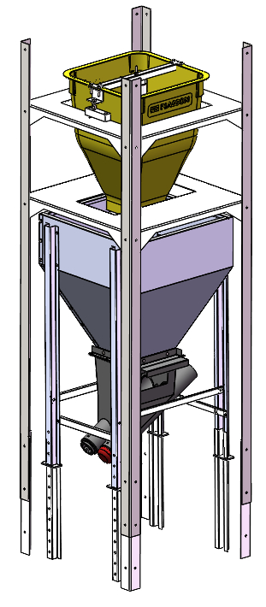

b. Motorized Feed T-Drops
- Assemble the T-Drop & Shut-off.
- Install the T-Drops on the Cross Auger – ensure they are above the hoppers of the chain circuits / feeding lines.
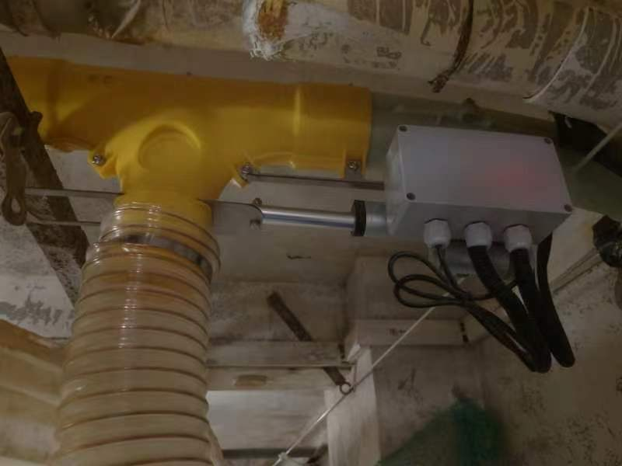
- Connect each drop with its motor, actuating steel arm and control box.

Electrical Installation
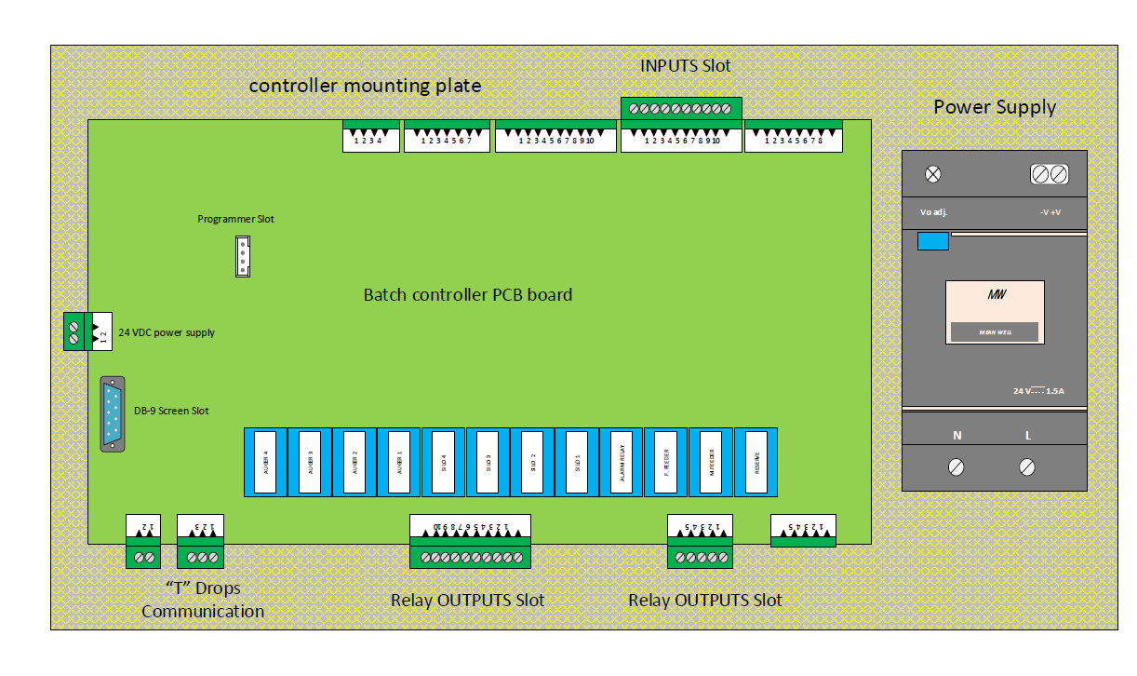
* All wiring must be conducted by an authorized electrician.

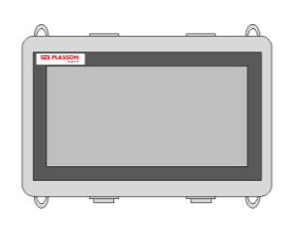

Main board wiring – power supply, output relay

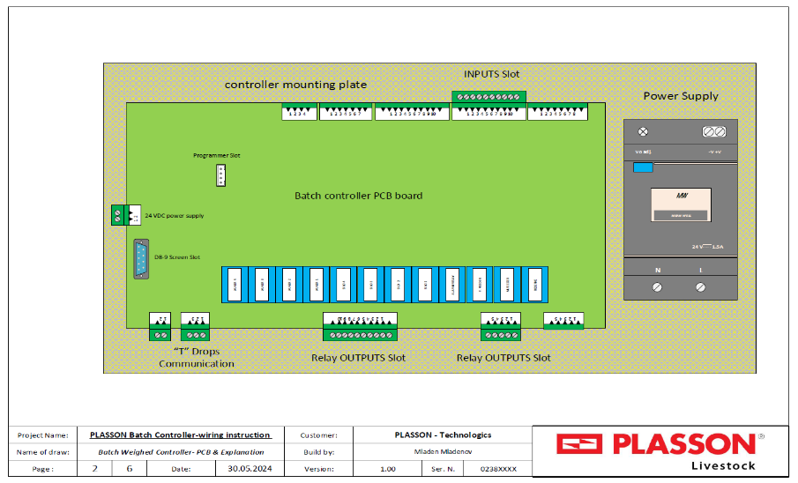
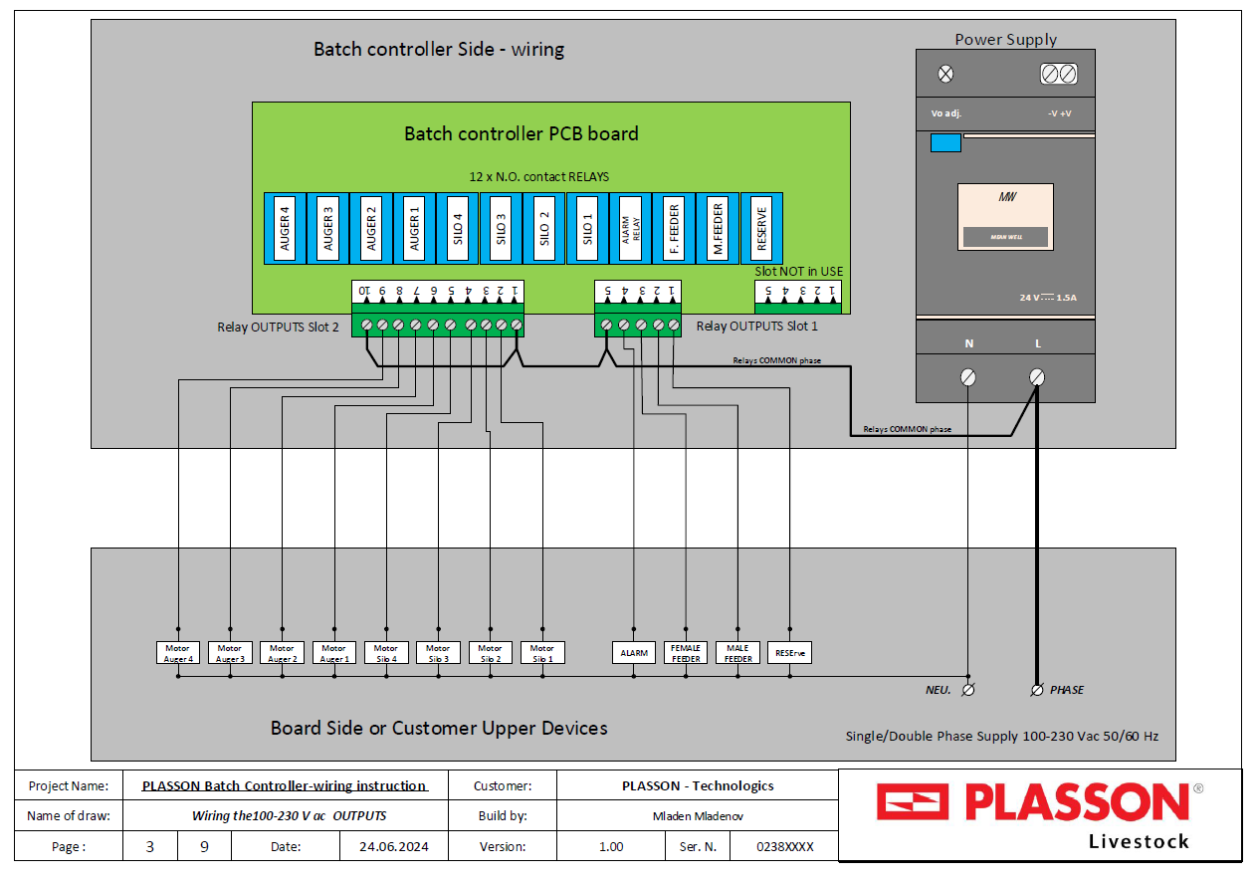

Main board wiring – Inputs

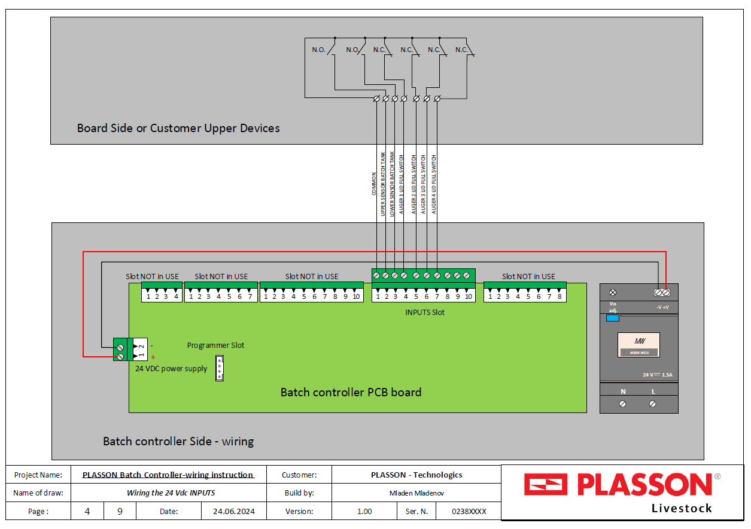

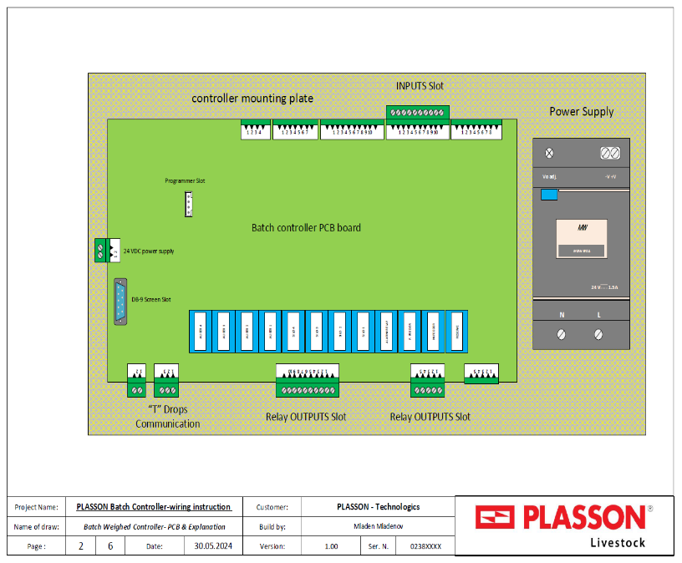

Tee Drop – electric card

- 12 v power supply
- Load cell
- RS485 Tee drops communication
- Dc motor actuator (Tee drop or weighing drum)
- Feed presentation
- Dip-switch for RS485 address
- Manual open close switch (Dip 8 off)
- RY1 & RY2 open/close DC motor actuator relays
- RY3 Feed presentation relay
- Slot for 2 load cell option

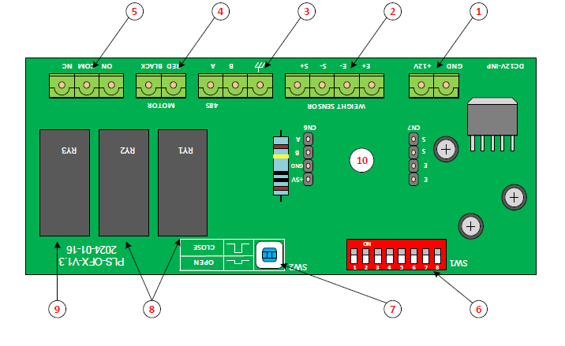

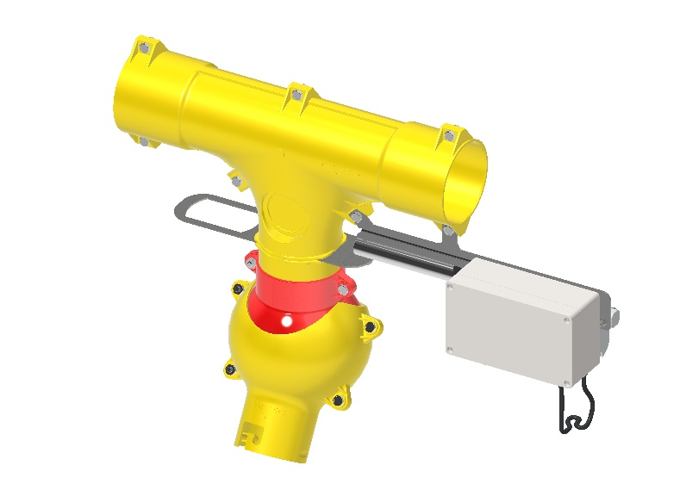
T - Drop – electric card

- Tee Drop
- Shut-off plate
- DC Motor actuator
- Electric card

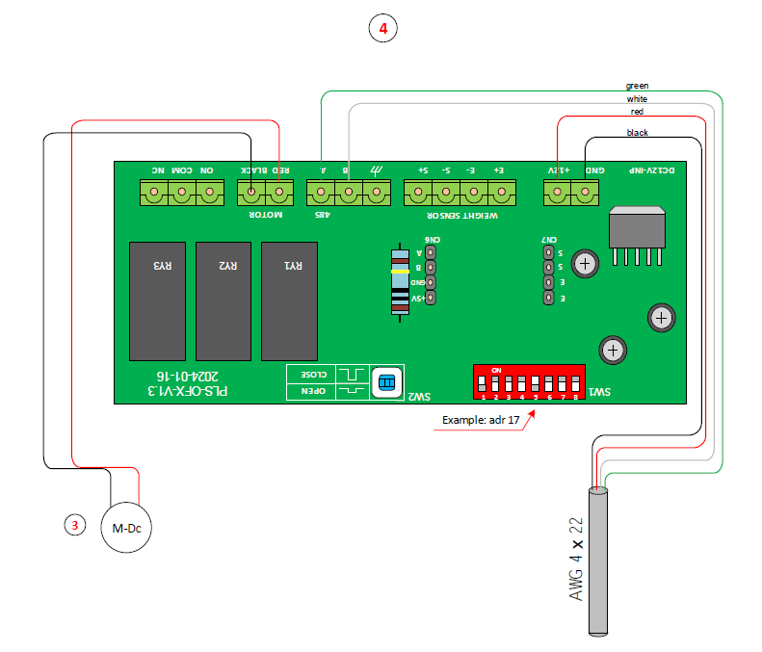

Main board wiring – Feed T-Drops and Weighing Load Cell

Motorized T-Drops wiring
- Using a 4-wire cable – run a serial connection between all T-Drops units and the Controller.
- Wire each T-Drop Motor to a 12 VDC power supply and a RS 485 communication cable.
- Note - Polarity applies.
Weighing Unit (Load Cell) wiring
- Follow the above T-Drops wiring procedure.
- The Load Cell is wired as part of the serial connection of the drops.
- The “Address” for the weighing unit will always be – 25.
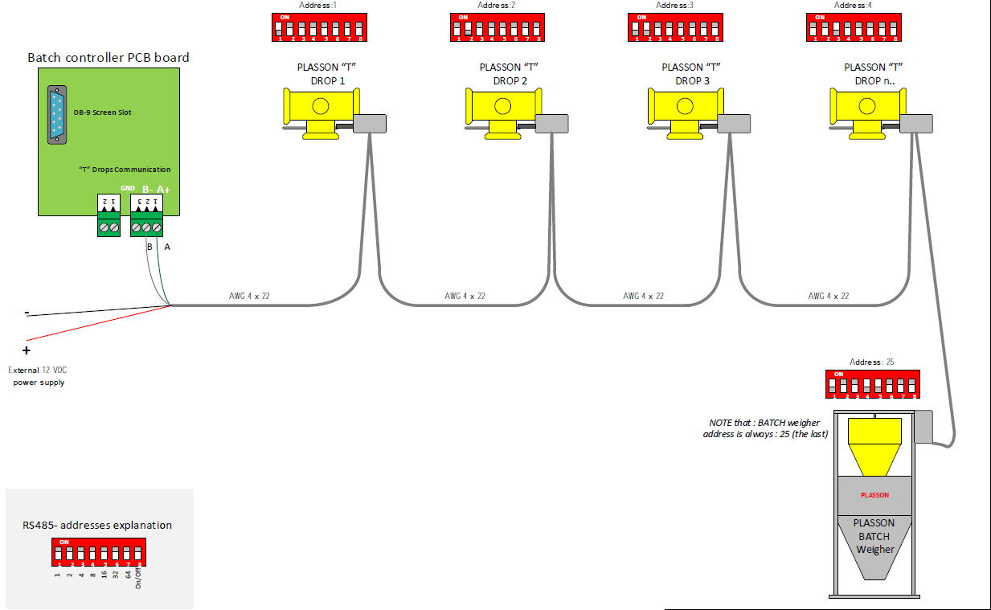

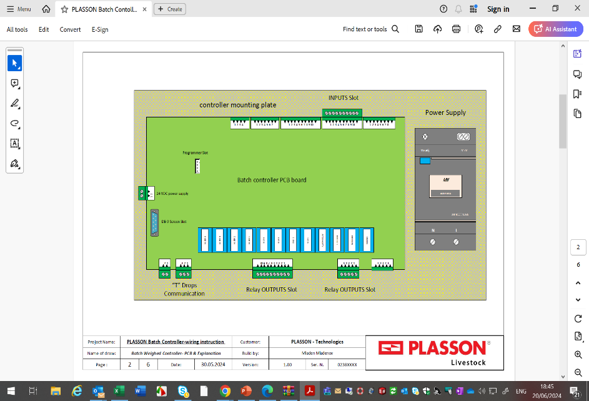

Weighing drum wiring

- Hoppers
- DC actuator motor
- Load cell
- Electric card (the same card as the T-Drop card)

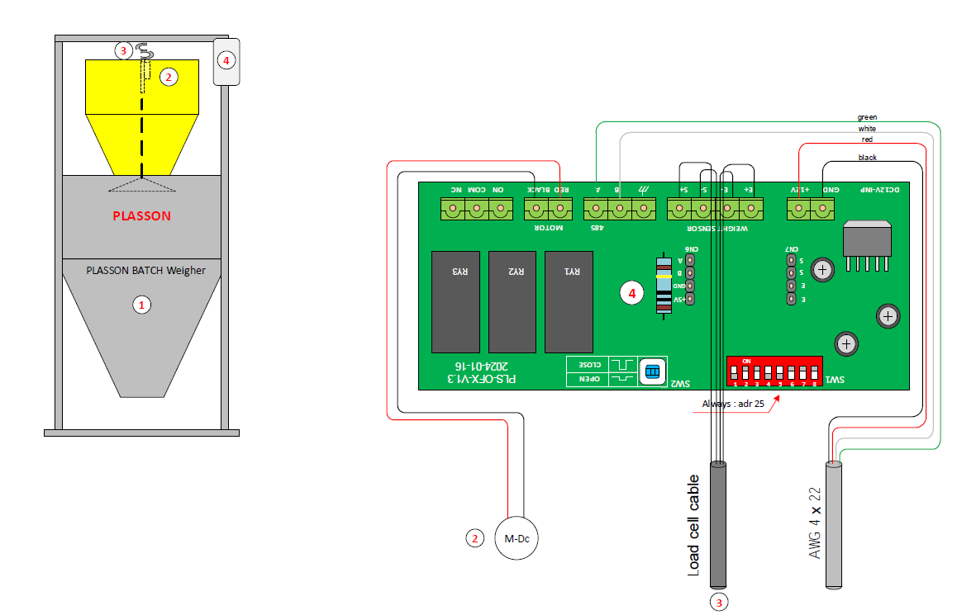

Setting Addresses of system components

Each electric component wired with a communication cable, must get an address for identification.
Addresses scope:
- No. 1-24: for the motorized T- Drops
- No. 25 (always) – for the weighing unit (Load Cell)
- If an address out of scope is given – the system will notify with an ERROR.
Note: Addresses are given (and changed) by setting combination of dip switches
in each component (8 switches per dip switch)
(ON = 0, Off = 1)

Manual T-Drop Open / Close
- If communication is lost a manual option to open and close the drops is available.
- Open the specific drop card and change dip switch No. 8 to “OFF”.
Press the WS2 button to open/close the shut-off.
- Change back “ON” when finished.
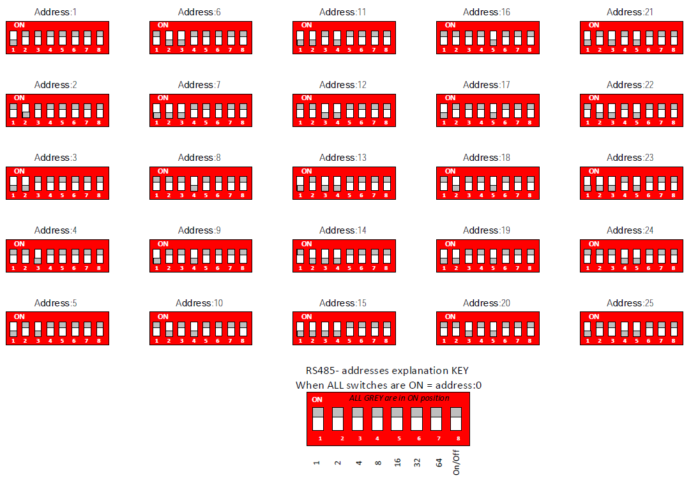

Main Screen
The Main Screen displays all system components and their Status.
Controlling the entire system is done on this screen as well as accessing all other menus in the controller.

- Augers and Feeders Status – while working the Icon will change color.
- Next Feeding Day and Total feed weighed today.
- T – Drops Status – 4 options: Waiting / Need / Feeding / Done
- Load Cell Status – showing the current feed weigh reading – online.
- START / STOP Button – START = Auto Mode. STOP = Manual Mode.
- Controller Status – START / STOP
- Lower Hopper Limit Switch’s Status.
- Alarms and Errors button – push to display all Errors. Button will flicker during error.
- Current Birds Age.
- Access to all controller programming screens.
- Current Date & Time
- Controller Version
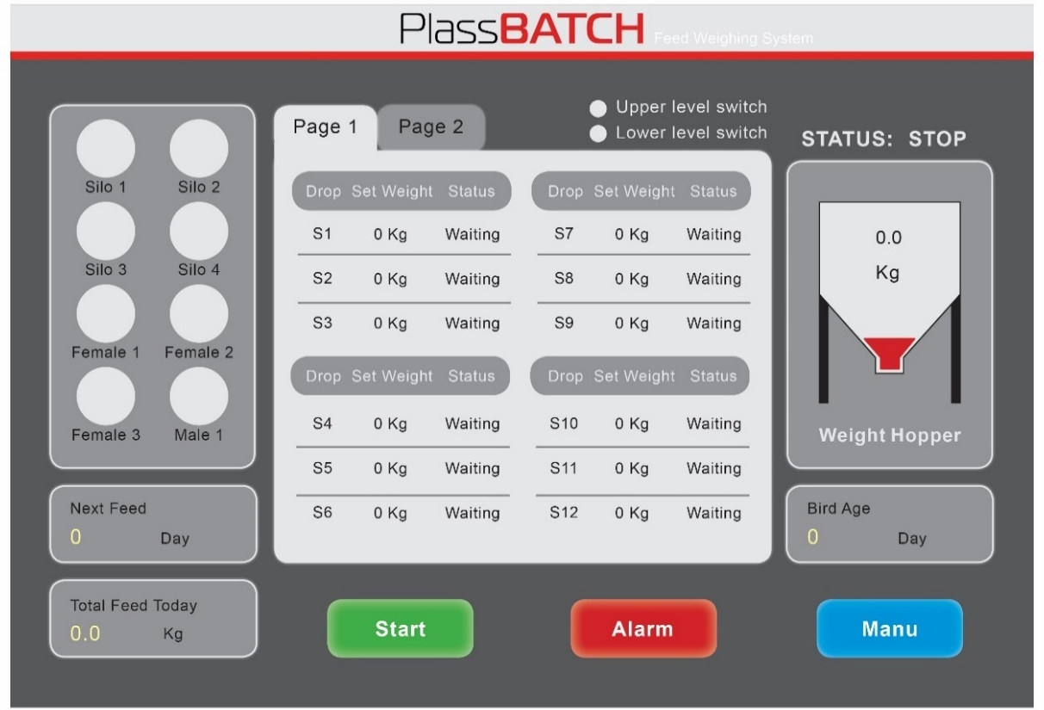

Setting Menus Screen
Navigate through the different applications to set and program the system.
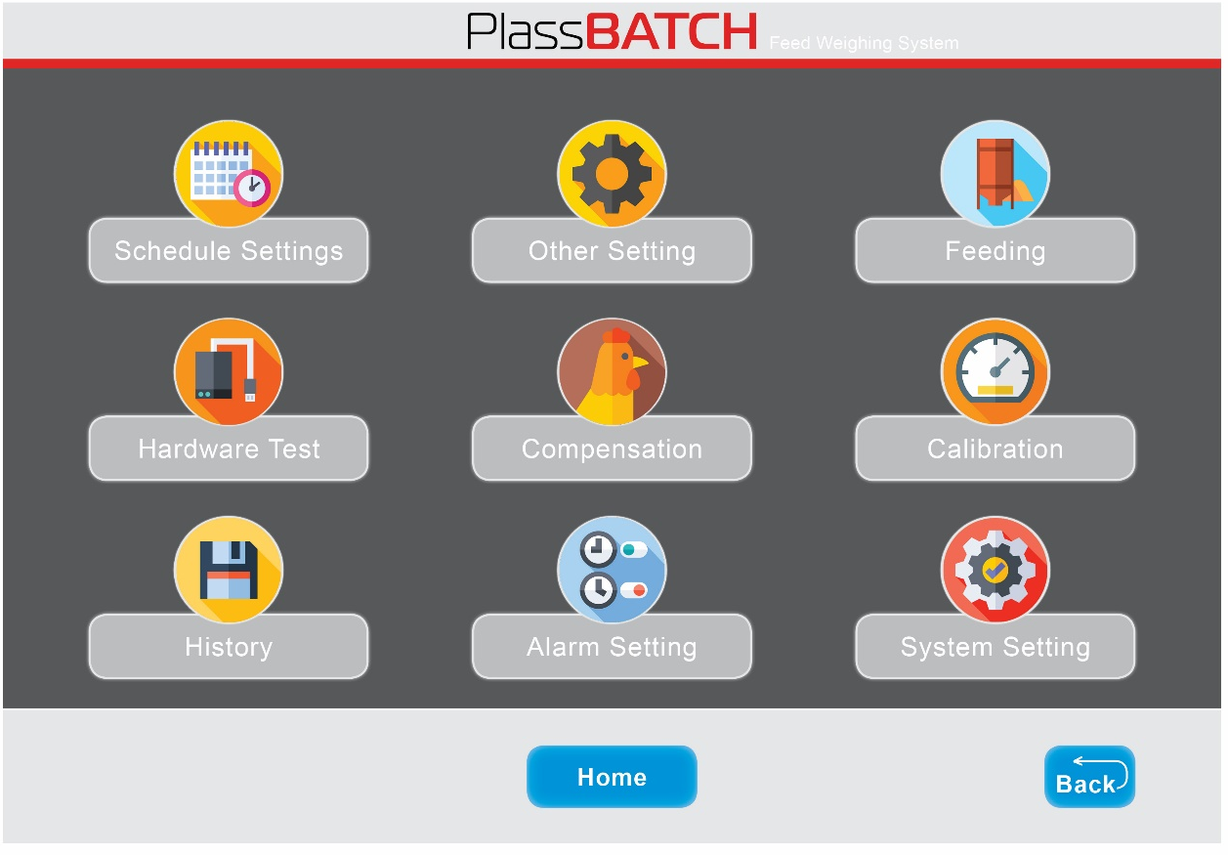

- Schedule Setting – Program the schedule plan for the T-Drops.
- Other Setting – Define feeding days and settings of the Augers from weighing station to
T-Drops.
- Feeding – Programing the feeders operation plan (Chan Circuits / Pan Loops / Pan Lines).
- Hardware Test – Manual activation of any specific component in the system.
- Compensation – Setting a fixed compensation (in gr. / kg) to each Drop and Load Cell.
Results in better accuracy of the total portion provided to the feeders.
- Calibration – Calibration of the Load Cell (Weighing unit).
- History – Display of daily and monthly weighing readings.
- Alarm Setting – Setting system Alarms and their Delay times.
- System Setting – General system settings.


System Settings

In this screen, General setting and the system mode are defined.
Set-up of new system for the first time must begin with this screen.

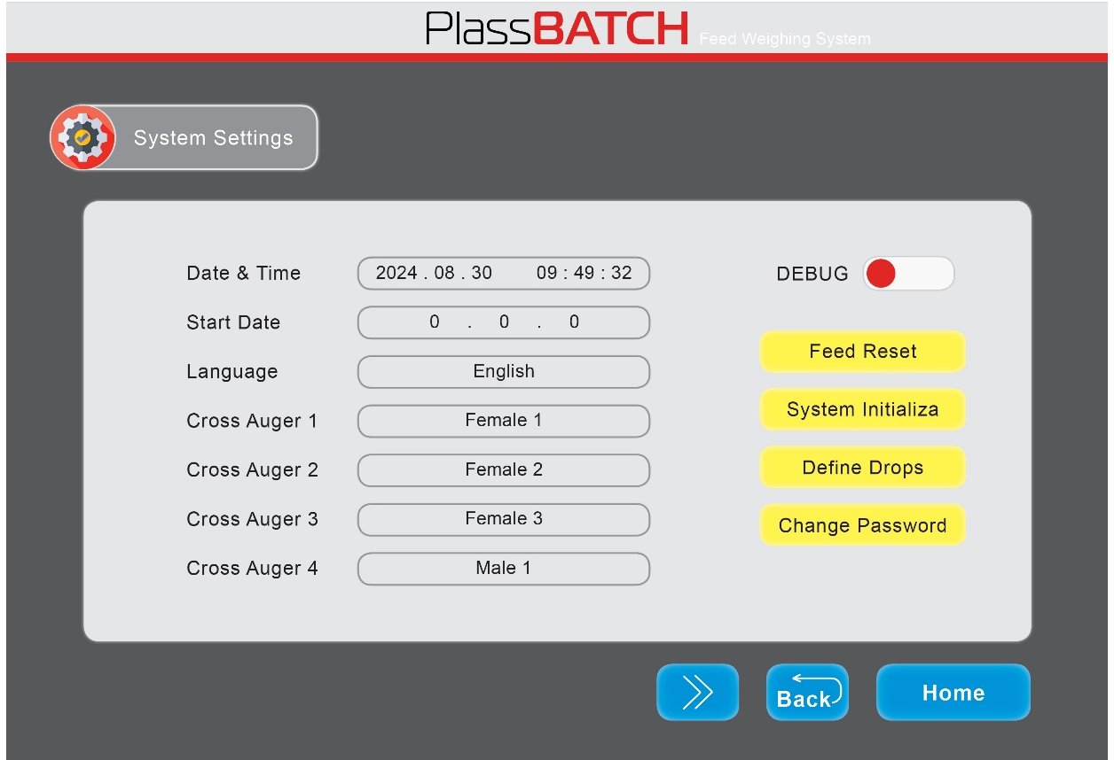

- Set the Date & Time
- Enter current birds' age.
- Choose your preferred Language.
- Cross Auger (1-4): Name each Cross Auger (Female 1-4 / Male 1-4 / No Use) to match its relay in the controller.
- Feed Reset – Reset of the T-Drops set-up, stops and clears current active plan.
Note – Any change in the screen “Define Drops” requires applying “Feed Reset”.
- System Initializer – clears all system setting – apart of the date & Time)
- Define Drops – define T-Drops and their location in the house and feeding plan.
- Change Password for your system
- Motor Direction – Keep System default = Reverse. Consult with Plasson Technicians for further options.
- Unit of Weight – Choose kg / lb. System default = kg.

- Lower Limit Switch – a safety switch in the weighing unit Plastic hopper. Choose Use / Not Use.
- Feeding Mode – Choose the controller operating mode: Normal Mode / Broiler Mode. System Default = Normal Mode
- Default Feed Port – Choose Communication / No Communication. Choose Communication if a card is installed in the last drop control unit (for Feed Presentation option). System default = No Communication.
- Weighing Module – Choose Weighing Module 1 / Weighing Module 2. System Default = Weighing Module 1
- Silo Quantity Set – Set the no. of Silo’s supplying feed to the weighing unit. 1-4 Silos.

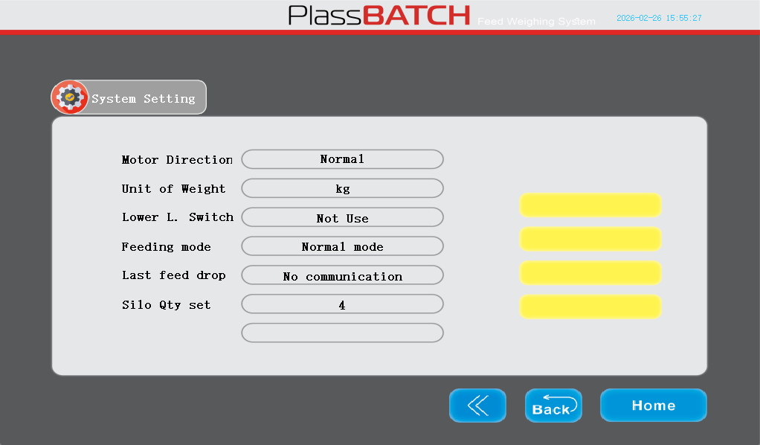

Broiler mode
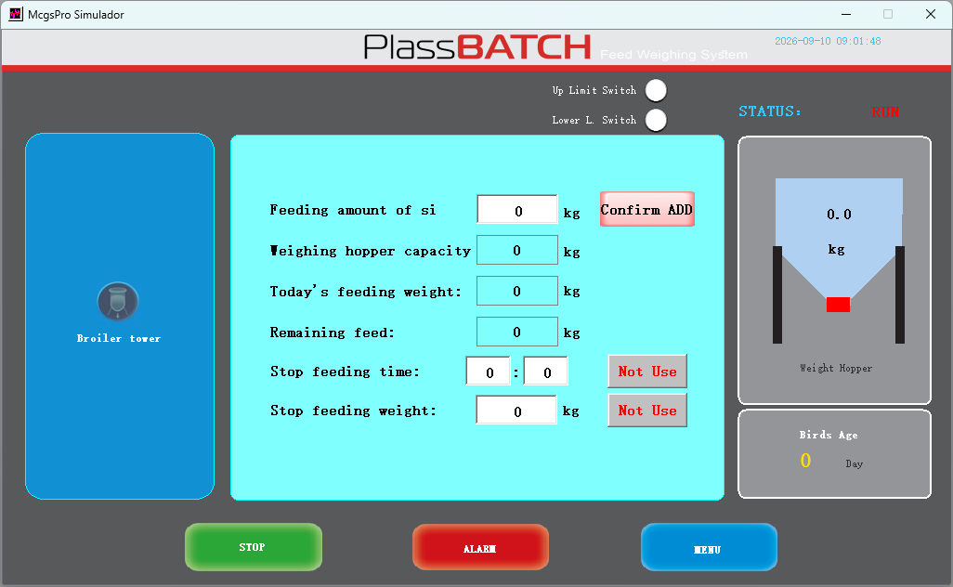

Choosing “Broiler Mode” in the system setting screen will presents a dedicated screen with an option for weighing the feed transported from the Silos to the feeders inside the house.
The user enters the total feed weight in the Silos. While the weighing unit pulls feed – the controller will calculate the feed moved to the feeders in the house and the feed left in the Silos.
- Increase feed weight – enter the feed Qty (kg) added to the Silo, and press “ADD”.
- Weighing Hopper Capacity– enter the exact weight of a single batch.
- Today’s Feeding Weight – display of the total qty (kg) of feed weighted today.
- Stop Feeding Time – Set an hour for the system to stop weighing. The system will resume weighing the following day.
- Stop Feeding Weight – Set a total feed weight for the system to stop weighing. The system will resume weighing the following day.
Notes:
- The system will operate the cross Auger into the house as long as the lower hopper safety switch allows it (there is feed in the lower hopper).
- The upper weighing hopper will not pull feed as long as the lower hopper is full with feed (indication from the upper Safety switch).
Define Drops
- This screen displays the feeder circuits chosen in the “System Setting” menu.
- Tick the boxes to assign T-drops to the different feeder circuits.
Notes:
- The last line drop must be also assigned, even in “No communication” set-up (no card in the last drop).
- In cases of “Feed Presentation” method, a card will be installed in the last drop. This way the entire portion can be charged to the circuit.
- Access to this screen requires a Password.

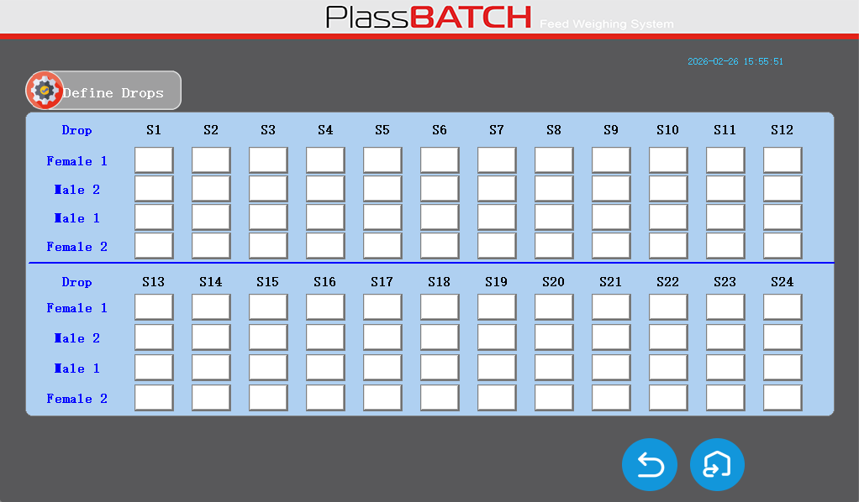


Schedule Setting

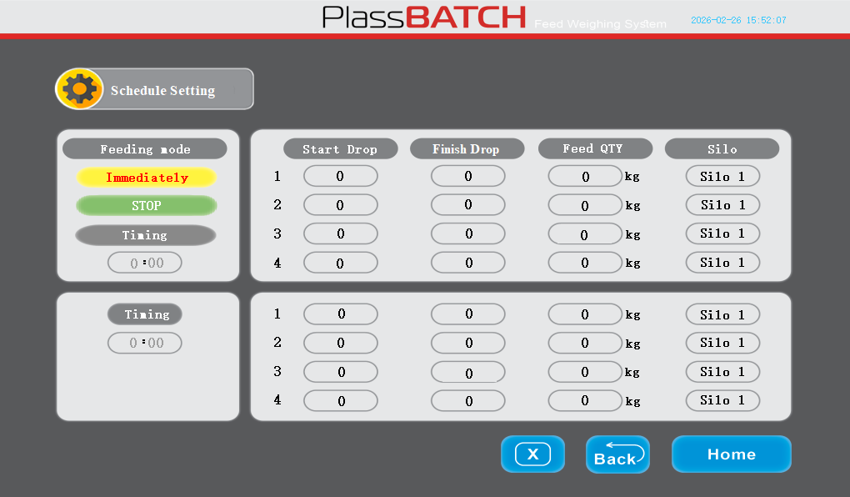

In this screen the user can set the feed qty for each drops group. In addition, each drops group is assigned to a specific Silo to supply the feed.
Schedule Options:
  - Up to 8 different feed portions can be programmed for a single feeding cycle.
  - Up to 4 different feed portions divided to two feeding cycles.
- Start Drop – The first drop in the group.
- Finish Drop – The last drop in the group.
- Feed Qty – the feed portion to be weighed and sent to the group.
- Silo – the silo from which the feed will be transported to the group.
- Feeding Mode –
  - Timing – feeding schedule is programmed to a chosen time. 2 times can be scheduled per day.

Note: Each T-Drop can only be assigned to one group in each feeding cycle. When two cycles are timed – the same drop can be assigned twice.

- Feeding Mode –
b. Immediately – the system will immediately execute the weighing and feeding of only the first 4 lines.
Note: Each T-Drop can only be assigned to one group in each feeding cycle. When two cycles are timed – the same drop can be assigned twice.
When switching from “Timing” mode to “Immediately” mode the system automatically goes to “STOP” status.
- Go to the main screen and set the system to RUN – this will activate the 4 first
lines plan.
- Once the feeding cycle is completed – the system will go back to “STOP” mode.
- To go back to “Timing” mode – press the “Timing” button, then go to the main screen and press “RUN”.

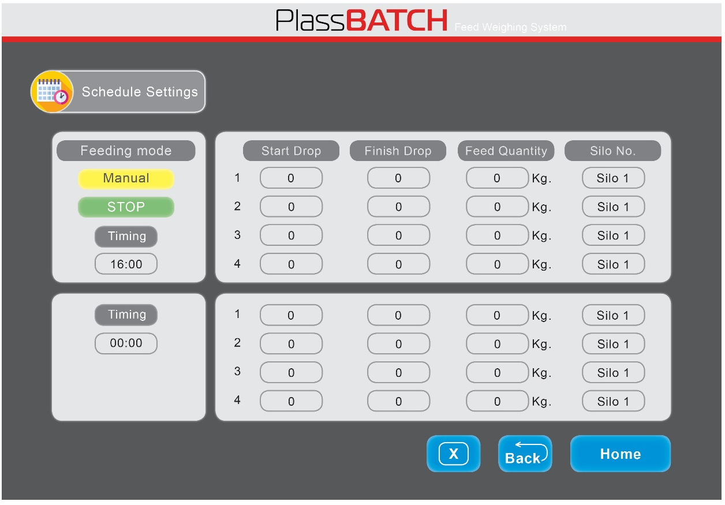

Other Setting

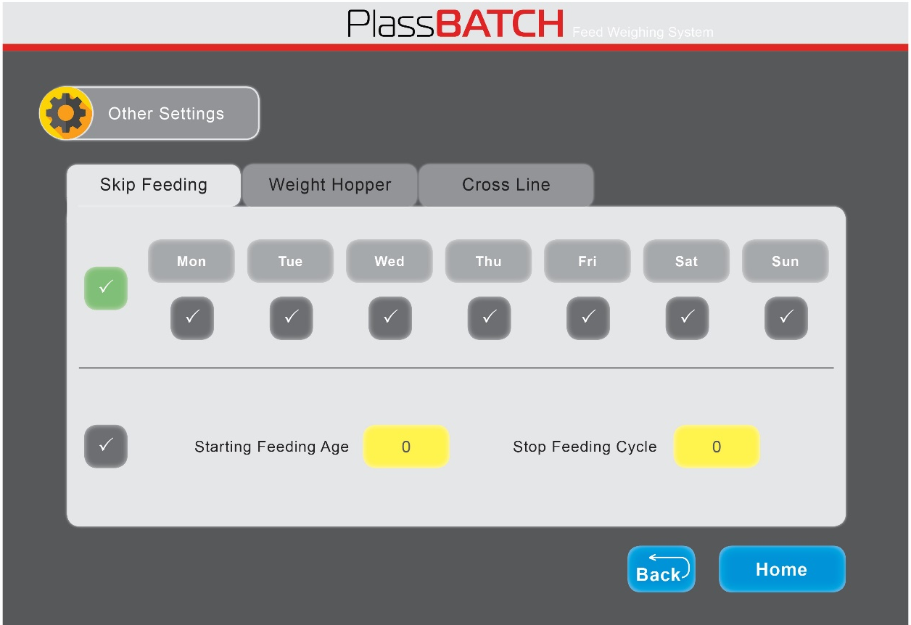

In this screen the user is setting the Feeding Cycles.

Skip Feeding
Set the weighing schedule based on:
- Days of the week
Or
- No. of days per cycle

In the main screen the next feeding day will be displayed based on the plan created.

Other Setting

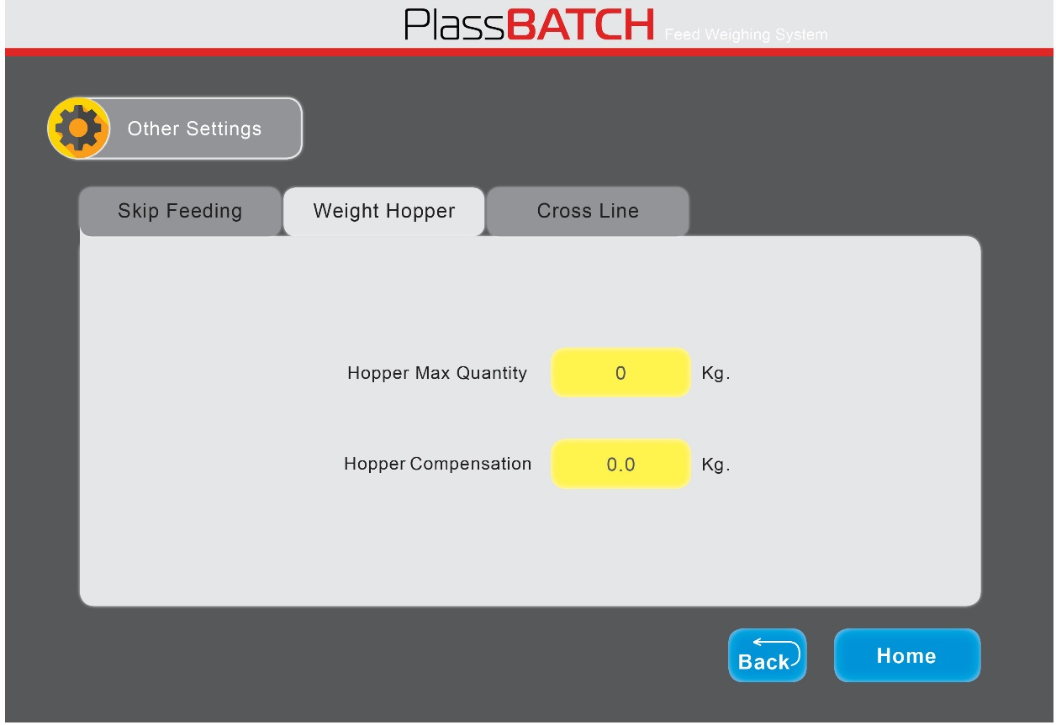

In this screen the user can set parameters for the Weight Hopper.
Hopper Max Qty – set a Max weight for a single batch.
Example:
Hopper Max Qty – 25 kg
Total feed portion – 250 kg
The system will weigh 10 batches x 25 kg.
Hopper Compensation – set a fixed compensation weight to improve the hopper weighing result.
  - Weigh on the weighing unit a 20kg portion.
  - Collect the feed in the weighing hopper and re-weigh it on an external accurate scale.
  - Based on the result – adjust the single batch weight.
if the result is lower than 20kg – add the missing weight.
if the result is higher than 20kg – reduce the extra weight.

Other Setting

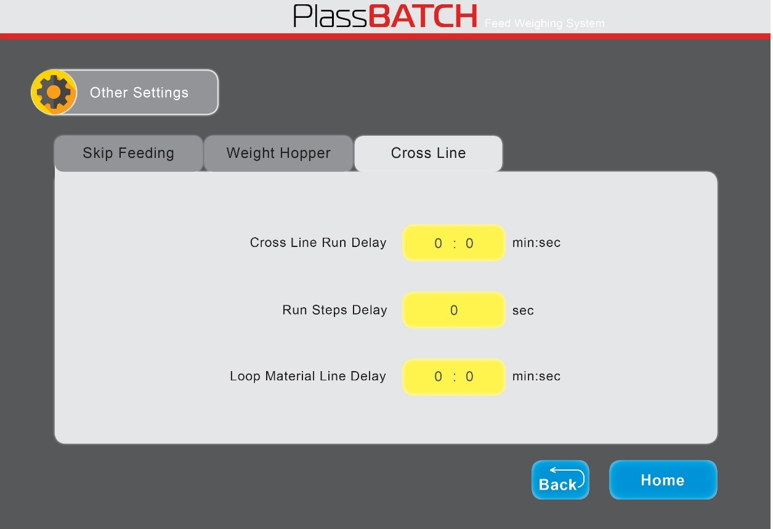

Cross Lines
- Cross Line Run Delay – Set a delay time in which the cross auger continues working after the weighing unit completed the portion (to ensure the cross auger is completely empty).
- Run Step Delay – Set a delay time after each batch of feed drops from the weighing hopper and a new batch arrives from the silo.
- Chain Feeder Fill Time – The time required for charging a full portion in the circuit.


Feeding

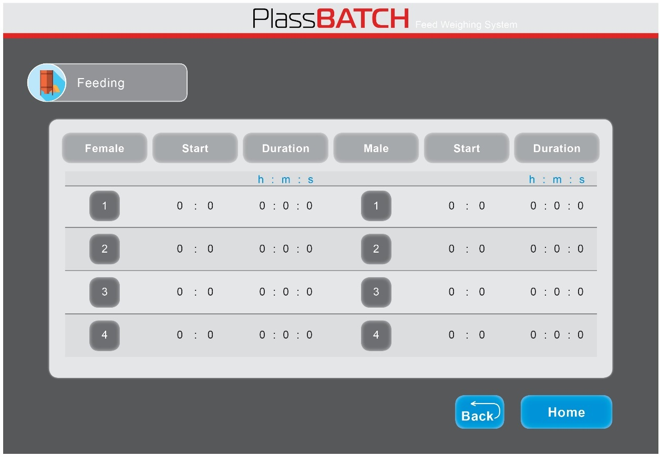

In this screen the user can program the schedule for the feeders inside the house.
- Set the schedule for the feeders. The system allows for 2 operations of 2 separate groups.
- Enter Start time and Duration for each group.
- Up to 4 operations for each group.


Hardware Test

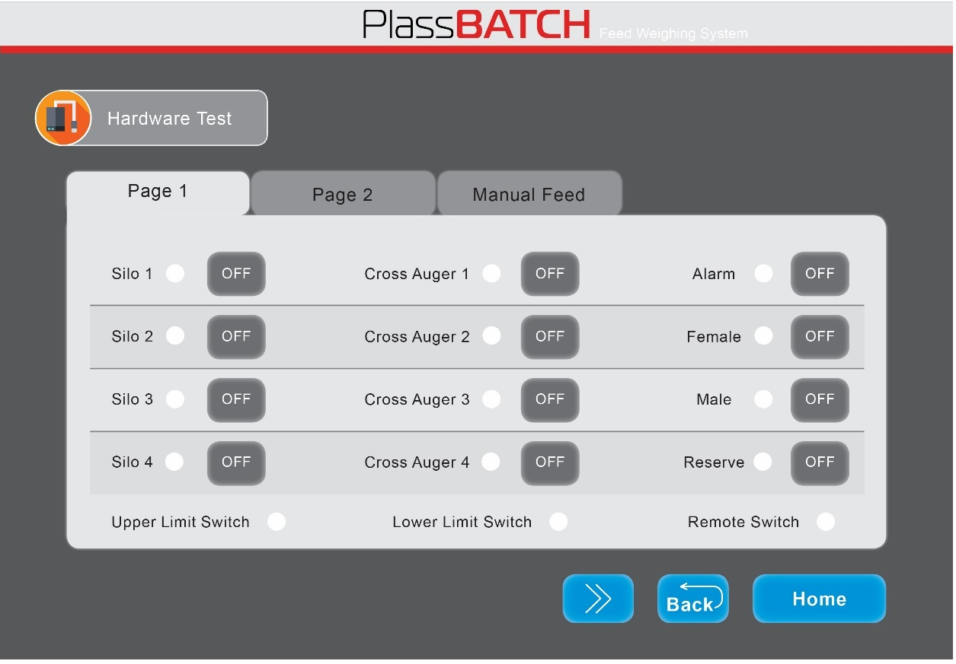

In this screen the user can test and activate all hardware components.
This function is not applicable while the system is in “Auto Mode”.
The system cannot be switched to “Auto Mode” while one of the components is tested.

- Switch a component to “ON” to activate it.
- Switch a component to “OFF” to stop it.

Hardware Test

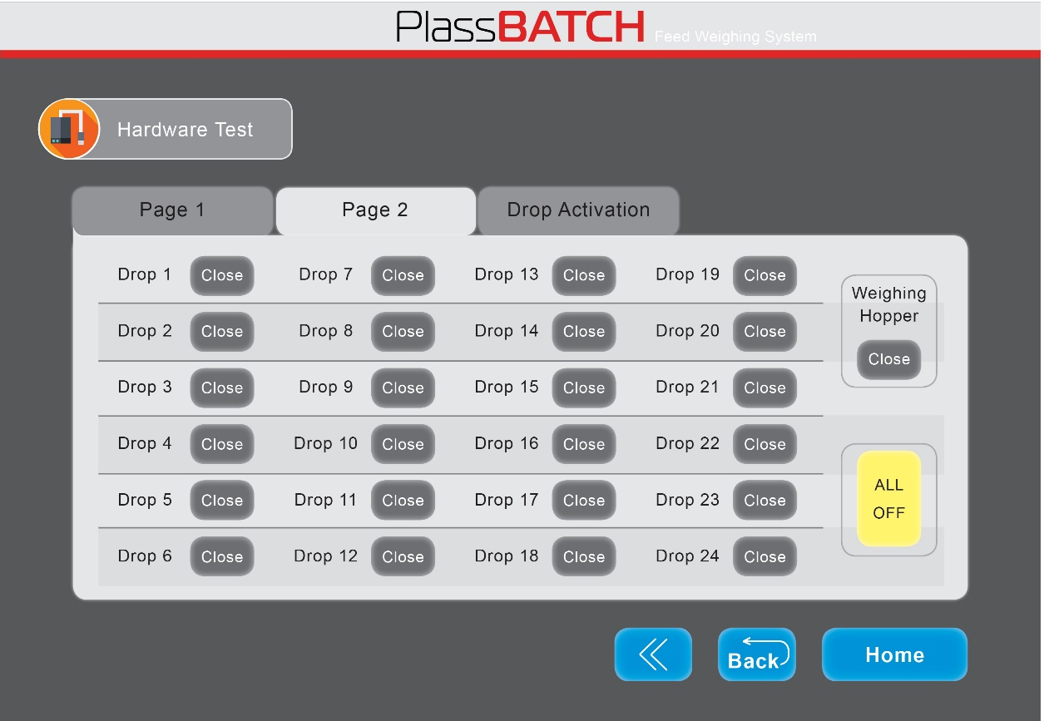

- Switch a Drop to “Open” to open it.
- Switch a Drop to “Close” to close it.

Hardware Test

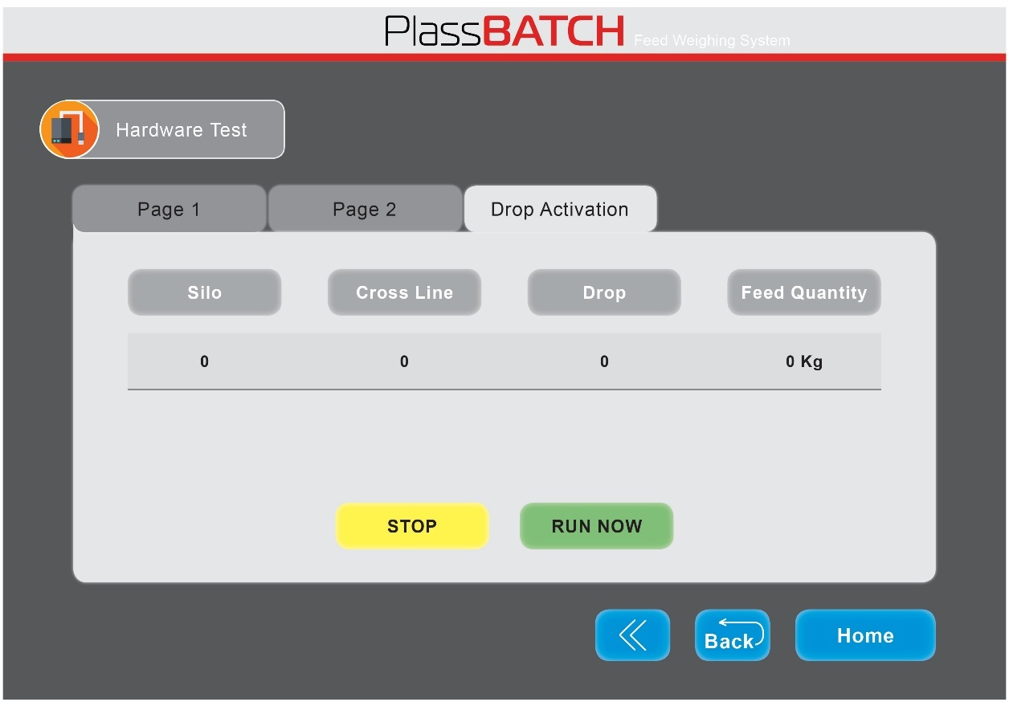

Manual operation for a single weighing.

To make a single weighing and activation of a single specific drop –
- Press “STOP”
- Enter the details for the required feeding.
- Enter “RUN NOW”
The system will run the weighing process and once completed will remain in “STOP” mode.


Compensation

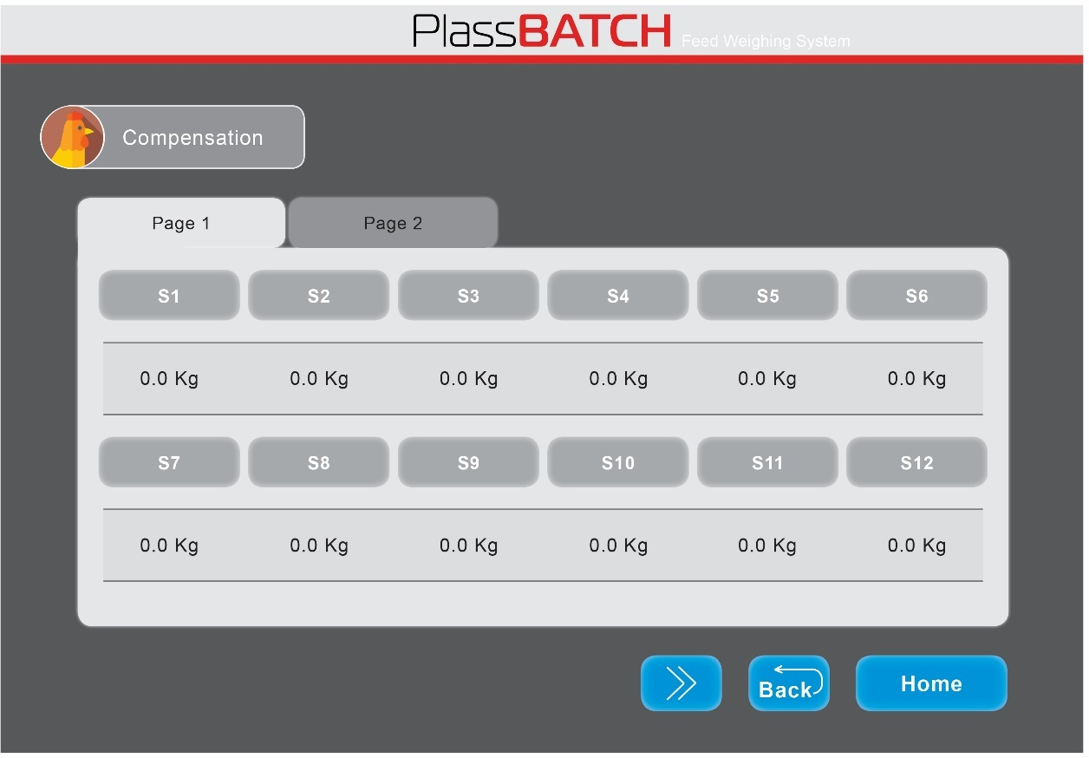

Setting a compensation weight for the T-drop

T-Drop Compensation – set a fixed compensation weight to improve the portioning result.
  - Weigh each T-Drop with 250gr (0.55lb) feed.
  - Collect the feed from the T-Drop and re-weigh it on an external accurate scale.
  - Based on the result – adjust the weight.
if the result is lower than 20kg – add the missing weight.
if the result is higher than 20kg – reduce the extra weight.

In systems with more than 12 T-drops, “Page 2” screen is available.


Calibration

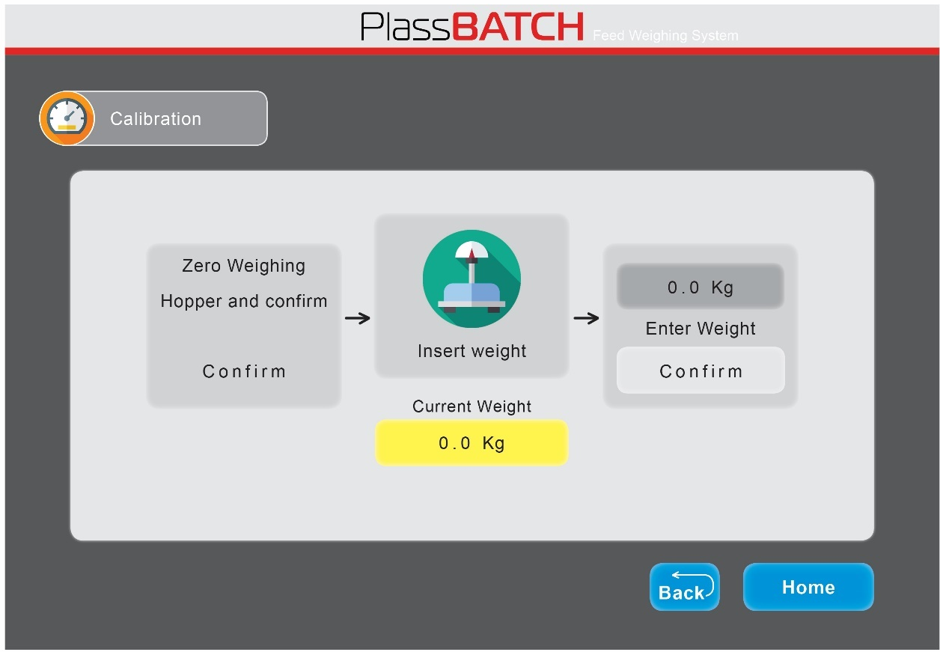

Calibration Process:
- Ensure the weighing hopper is empty – then press “Confirm” (Zeros W. Hopper).
- A white window will open – enter the calibrating weight (recommended 10kg)
- Put a 10kg weight (must be accurate – exactly 10kg).
- Compare and adjust the weight to exactly match.
- Wait for the system to confirm the calibration.
- Take the 10kg weight out and ensure the weight goes back to Zero.
- Note: if the system is operated in lb. the calibration must be done in lb.


Alarm Setting

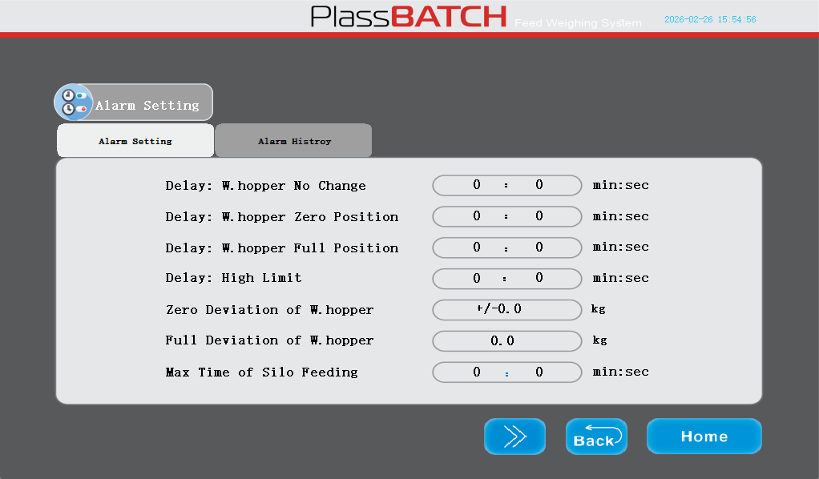
Setting Alarms Delay times and parameters Deviation

- Delay: W. Hopper No Change – Time delay for no change in W. hopper weight
(Paddle stuck half open).
- Delay: W. Hopper Zero Position – Time delay for no filling of the W. Hopper
(problem with the Auger from the Silo).
- Delay: W. Hopper Full Position – Time delay for the W. hopper remaining full
(Paddle motor not working).
- Delay: High Limit – Time delay for alarming Lower Hopper Over-flow.
- Delay: Zero Deviation of W. Hopper – Allowed deviation from the W. Hopper
Zero weight.
- Delay: Full Deviation of W. Hopper – Allowed deviation from the W. Hopper
Max. Weight.
- Delay: Max. time of Silo Feeding – Max. time for the Silo auger to fill the W. Hopper.

Alarm Setting

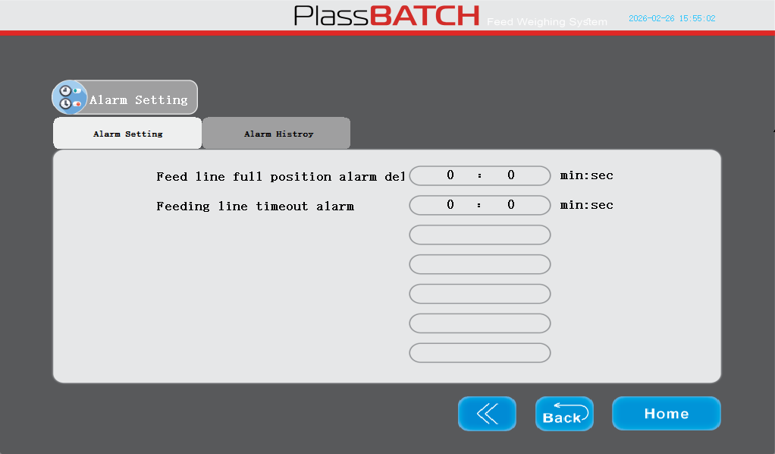

- Delay: Feed Line Full Position Alarm Delay, Cross auger Over-Flow
- Delay: Feeding Line Timeout Alarm – Time delay in case cross auger not emptying the lower hopper


Plasson Feed Weighing System
Installation & Operation manual

